(Approx. 1,107 words)

Windows 7 Live
By Dick Maybach, Member, Brookdale Computer Users’ Group, NJ
January 2013 issue
www.bcug.com
n2nd (at) charter.net

Over the years, Microsoft has named several offerings “Windows Live,” and the name again returned with Windows 7. However, much of it is available as a no-cost download, rather than being bundled with the installation DVD. To confuse matters further, some PCs are delivered with all or a portion of it installed. Despite this rather off-hand treatment of it, Windows Live can be a valuable addition, one that you may use every day. In this article, I hope to introduce you to what it can offer, but like any complex service, making effective use of it will probably require some study.
Unfortunately, because the service is changing, most of the books and Internet articles on it are out of date. They can be helpful, but you must read with care.

The programs available in a package called Windows Live Essentials and include:
- Mail – an e-mail client that replaces Vista's Windows Mail and Outlook Express from earlier versions,
- Photo Gallery – a much improved version of Vista's Photo Gallery, that lets you edit, organize, and publish your pictures,
- Movie Maker – provides similar capabilities for movies,
- Messenger – a descendant of MSN Messenger that provides access to instant messaging, chat, and social media networks such as Facebook,
- Family Safety – allows parents to limit their children's Internet access, and
- Writer – lets you create and manage blogs.

The cloud services, which become available when you sign up for a Windows Live account, are:
- Sky Drive – which provides a generous seven Gbytes of storage without charge, for your own use or to share with others and
- Wordpress – which is a blogging host that replaces Spaces, a similar service earlier provided by Microsoft.

Two other Microsoft services, Skype video conferencing and Hotmail, are related to these, but so far offered separately, although both can easily be accessed while using Messenger.

You can download the programs from http://windows.microsoft.com/en-US/windows7/products/features/windows-essentials. Note on the screen-shot below that you can download the individual programs or everything at once.
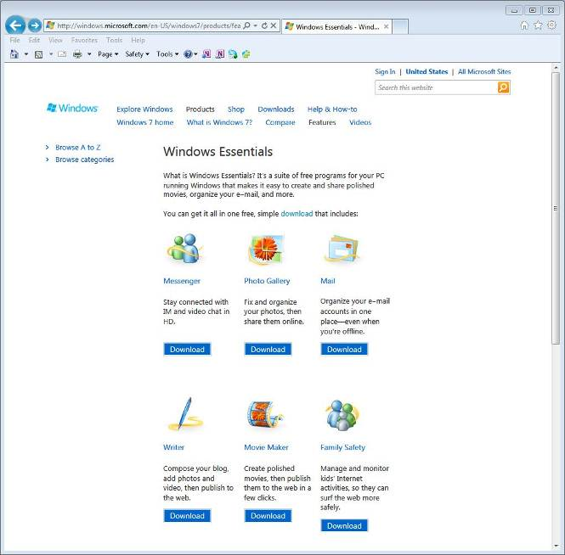
You probably already have a Windows Live account. If not, or to make changes, go to https://account.live.com.

Set up SkyDrive by tapping the Windows key, typing “sky”, and selecting Microsoft SkyDrive. Follow the instructions and you will find the new directory SkyDrive in your home folder. Anything you place in it will be available to your other PCs that also have SkyDrive installed. You may see references to Mesh in some documentation, a service that allowed you to synchronize folders among PCs, but this was discontinued in the 2012 version of Essentials. Instead, just place any folders to be synchronized in your SkyDrive folder. However, if your PC came with Essentials installed, you may find Mesh in it. The first time you run SkyDrive on a PC, it will take you to the Microsoft Live Web page (https://account.live.com), where you will log into your account. After this, running SkyDrive will just open the Directory, and you will have to go to the SkyDrive Web page (https://skydrive.live.com/) to make changes in your account. Note that the files in the SkyDrive directory reside on every PC, as well as in the cloud. If you aren't connected to the Internet, you still can access them, but they won't be synchronized until you connect. To share files and directories with others, go to the SkyDrive Web page, right-click on the file or directory, select Share, and enter an e-mail address. You will be led through composing an e-mail message to them that will include a link to the item or items to be shared. By default, the Recipients can edit option is selected, which allows those recipients who have a Microsoft account to be able to sign in and edit the file or folder. If you are just sharing photos, you probably should disable this option. A second option requires your recipients to sign in with a Microsoft account before they can view the file or folder. This helps prevent your recipients from giving third parties access to your files or folders by forwarding the link to them. The choice in selecting this option depends on trade-offs among privacy, trust, and how much bother you want to impose of your recipients.

Start Messenger by tapping the Windows key, typing “mes”, and select Windows Live Messenger. It provides access to social networks such as Facebook and LinkedIn and provides for the exchange of instant messages. To make it useful you must provide the login information for your social networks and enter the contact information of those with whom you want to communicate. There is a trick to using Messenger – the menu bar is hidden by default; tap the Alt key to make it visible.

Start Mail by tapping the Windows key, typing “mail”, and selecting Windows Live Mail. This client program can provide access to any e-mail provider that allows POP access. (Most do.) I find it much more convenient than logging in to each account separately with a browser, since the messages from all your accounts show up in a single Live Mail window.

Windows Live Writer is a blog editor that works with many blog services. If you don't already have a blog account, the program will lead you through the steps to create one on Wordpress. Then, just start Writer and begin composing.

Windows Live Family Safety lets you protect your family by controlling Internet access and computer use. It allows you to block Websites, manage contact lists, limit computer time, and get reports on activity. For it to be effective, each user must have their own account and you must disable the guest account. Properly setting it up will take some time and will probably cause some frustration for your family. An alternate approach is to keep your PC in an area of the house where you can see the screen.

I discussed Photo Gallery and (very briefly) Movie Maker in my December 2012 BCUG Bytes article, available at http://www.bcug.com.

The functions of these programs aren't unique, as there are many alternatives. The Windows Live Essentials programs advantages are that they are free, easy to use, and are updated along with your other Microsoft software. A big plus is that Microsoft provides seven Gbytes of free cloud storage, a larger amount than the two to five Gbytes available with most other free services. A big disadvantage is their poor documentation. You will probably have to do some experimenting and perhaps some Web searches to make good use of them, especially since much of the available material describes earlier versions with different features.

